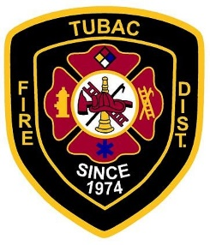**Tubac Fire Board Meeting**

**August, 2019**

**Staff Report**

**The mission of the Tubac Fire District is to create a safer environment within our community in order to increase the quality of life which our citizens may enjoy.**

**American Tower Update**

The current marketing agreement with American Tower expires May 23, 2024. Four companies pay a monthly lease through the American Tower marketing agreement: AT & T, Sprint PCS, Alltel Communications, and Voicestream PCS II Corp (T-Mobile).



American Tower has completed the required maintenance for the property and secured the site. Currently we are having a survey completed for the site so we can clearly delineate the property line from the adjacent neighbor’s driveway. Once the survey is complete, we will research fencing around the entire property to add security along with improved driveway access.

**Operations Update**

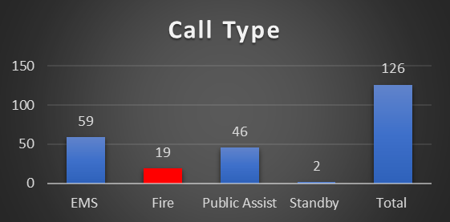

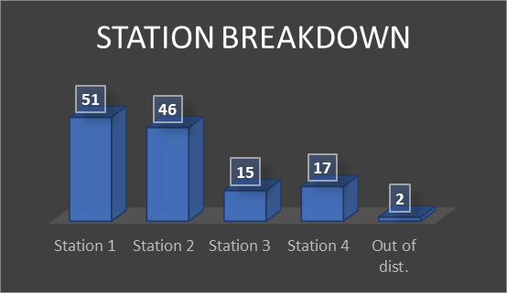

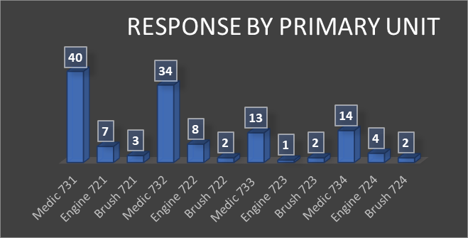

***EMS Response***

* Staff reviewed EMS 911 responses for the past month.

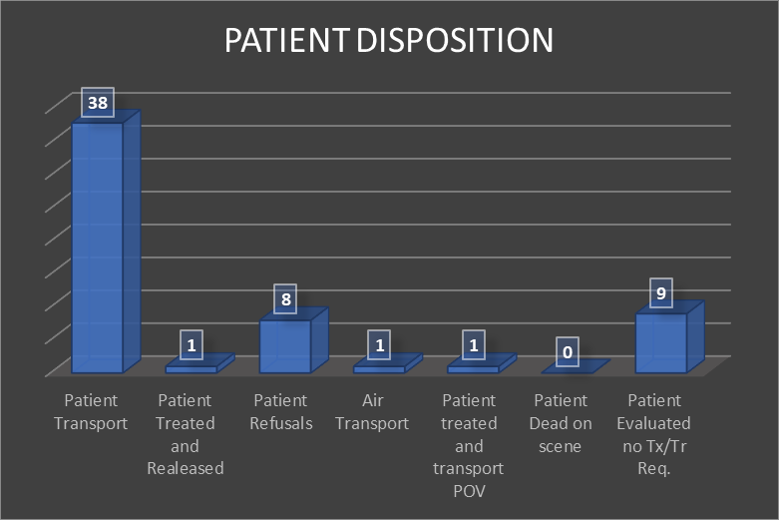

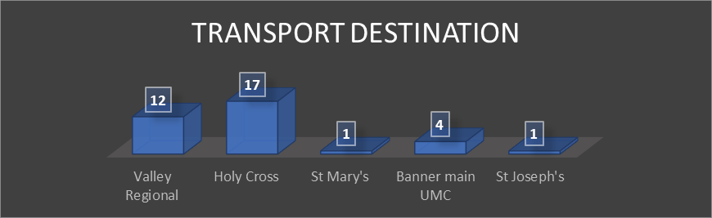

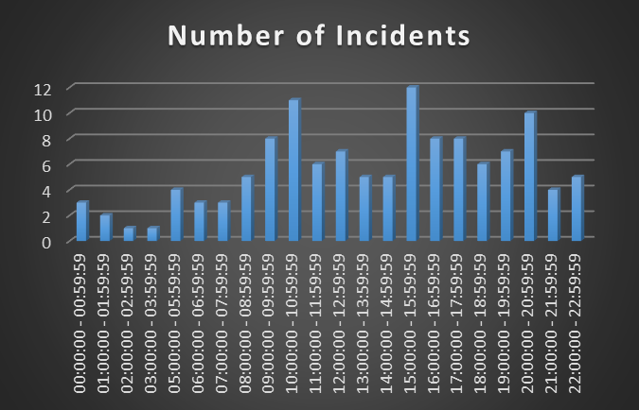

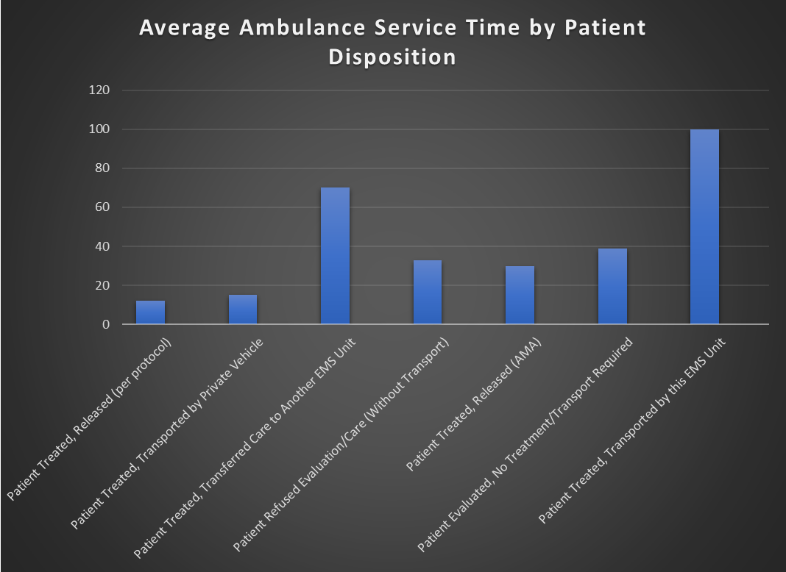

**Wildland Update**



**Administration Update**

Plan/Review Prevention:





